Call for Papers

International Symposium
The Future of Security in the Post-Pandemic Era:
Marine Security and Cyber Security

Presented by
The Foundation for Law and International Affairs
&
School of Marine Law and Humanities, Dalian Ocean University

Date and Location
October 22, 2022
Online & Dalian, China

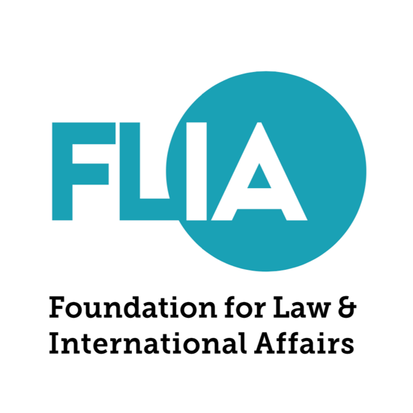

The Theme

The COVID-19 pandemic since 2020 has severely changed the landscape of the international economic and political foundation and the order of today’s global governance. Although it is very unlikely that the epidemic is going to “end” economic globalization, it has disrupted the established agenda and operating rhythm of globalization. Globalization has begun to transform and is moving towards regionalization, bilateralization and mini multilateralization. The economic pressure and self-preservation mindset caused by the pandemic has also profoundly reshaped the issues in focus of the law and international affairs studies towards the direction of international security, instead of development.

Among these traditional and non-traditional security issues, we believe that two fields are worth great attention -- Marine Security and Cyber Security.

In the field of Marine Security, first of all, the trend of counter-globalization has inhibited the willingness and motivation of global maritime cooperation. Anti-globalization and unilateralism are making the global ocean governance system established after World War II face unprecedented crises, and maritime governance cooperation between countries and regions has become more difficult and increasingly full of variables. In addition, maritime disputes and geopolitical competition have made cooperation between countries more difficult. Cooperation in the fields of marine environmental protection, maritime search and rescue, fishery resource conservation, and navigation safety has stalled due to the continuous interference of maritime disputes and competition among major powers.

In the field of Cyber Security, the pandemic has significantly moved our life to online scenarios. The new technologies and industries that are based on e-commerce, internet tech or data science have subverted the way we interact with each other in life and work, and are constantly upgrading our understanding of cyber security. While bringing great convenience to our society, internet governance also hides many dangerous security loopholes and potential problems. Beyond that, cyber security threats are emerging all over the world and can impact anyone, including sovereign powers, non-governmental organizations, international organizations and individuals.

There are increasing needs for better understanding of the rising issues regarding marine security and cyber security, and for developing the existing theories and frameworks, which raise these particular issues:

- Is it possible to establish a new type of pragmatic and protective internationalism from the perspective of preventing or governing traditional and non-traditional security threats?
- How can the existing theories based on the practice be developed in the field of maritime territorial disputes, maritime military power construction, maritime law and commercial order, marine ecology and environmental protection, and the sovereign relationship on maritime security?
- What are the new results in the field of marine research or survey?
- Who are the stakeholders of cyber security and what should their roles and responsibilities be?
- What would be reliable methods and ways for international cooperation to prevent and combat cybercrime, protect private information, and jointly govern cyberspace?
- How can less developed countries be assisted to protect their cyber security?

With these relevant questions in mind, the Foundation for Law and International Affairs Review and the School of Marine Law and Humanities, Dalian Ocean University invite fellow researchers and experts in all relevant disciplines to join our upcoming International Symposium titled “The Future of Security in the Post-Pandemic Era: Marine Security and Cyber Security” on October 22, 2022 to discuss these vital issues and present your work. We hope to discuss these important topics through two panels:

- Panel 1: Repacking Maritime Security and Maritime Law in the Post-Pandemic Era
- Panel 2: The Legal Preparedness for Cyber Security in the Post-Pandemic Era

In addition, with our mission of empowering the young generation and welcoming a more inclusive world, we invite world education leaders to join us to discuss how to equip students with the knowledge and skills to dissolve the false boundaries that have inhibited conventional thinking at the following panel:

- Panel 3: Critical Directions of Higher Education in the Next Decade Post-Pandemic Era

Submission

To participate in any of the panels, please submit a 250-500 word abstract, along with a copy of your resume, by Sunday, October 2, 2022. Submissions should be sent to contact@flia.org with the subject title “FLIA 2022 Conference + Panel number _.” The working language for these panels is English.

Publication

Selected papers may be published in the Spring 2023 issue of the Foundation for Law and International Affairs Review. To be considered for publication, completed papers should be between 8,000-10,000 words and in Western academic style, offering analysis or production of knowledge with an eye to the existing literature. Alternatively, papers can focus on rigorous policy analysis considering perspectives from leaders or academics in the field. The papers will be peer reviewed.

Expenses

There is no registration fee to attend the conference. Conference participants will be responsible for their own travel and accommodation expenses. Due to COVID-19 travel restrictions, participates are encouraged to attend the conference online.

Please feel free to contact us at contact@flia.org with any questions or concerns.

