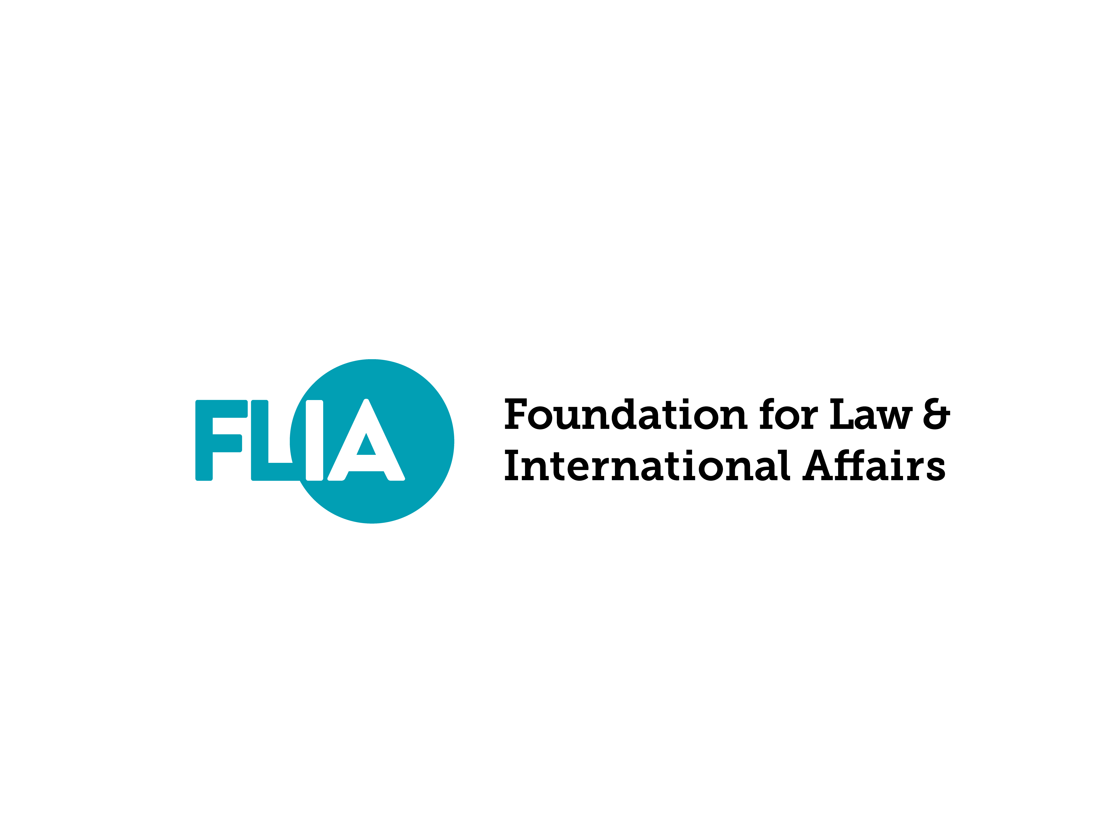
Foundation for Law and International Affairs

www.flia.org
1420 N Street NW, Suite 102, Washington, DC
Phone: +1 (814) 777 5228
E-mail: contact@flia.org

FLIA GlobalBrains Initiative Invitation

About the FLIA GlobalBrains Initiative

FLIA GlobalBrains Initiative is a professional community for young professionals at the intersection of law and international affairs.

If you are a young professional at the intersection of law and international affairs, we will feature your story and expertise to FLIA’s global network to enhance your opportunities for collaboration, publication, and job hunting.

We find it disappointing that most media outlets give all of their attention to technology and venture capital. Young professionals who are committed to the intersection of law and international affairs – which is the front line in the development of both globalization and localization – have not been given the value and opportunities they deserve.

Therefore, we are calling young professionals to join the FLIA GlobalBrains Initiative, where we will grow as a community and work towards the vision we all share for the future.

Benefits of Being a FLIA GlobalBrains Initiative Member

In addition to being featured, the benefits you can gain as a FLIA GlobalBrains Initiative Member include:

1. The possibility of becoming a FLIA Review Editorial Board member.

2. The possibility of joining the FLIA Insight Team and FLIA Consultation Team. The benefits of the FLIA Insight and Consultation teams include:

- Your original work will be published and circulated on FLIA’s global sources, or referred to our consultative client from public sector and private sectors, or published in FLIA electronic journals;
- You will have priorities over publishing your paper in FLIA Review, subject to their satisfaction with academic requirements;
- We will invite you to join FLIA’s various research projects.

3. The possibility of getting freelance jobs from FLIA alongside your daily work.

4. Receiving information on international conferences, grant opportunities, internship and job opportunities.

5. Receiving recommendations for job applications, independent freelance work, and potential employers.

Qualifications

As a FLIA GlobalBrains Initiative member, you have no obligations to FLIA. However, in order to maintain the professionalism and culture of the community, we do have minimum qualifications for prospective members. To be eligible to join the FLIA GlobalBrains Initiative, you must meet all necessary conditions and at least two optional conditions.

1. Necessary Conditions:

____(1) No academic fraud or other records of academic discipline;
____(2) Open-minded and non-discriminatory perspective on nationality;
____(3) Unique views on major international issues.

2. Optional Conditions:

____(1) Overseas education (i.e., studied abroad);
____(2) Completion of graduate degree or current enrollment in graduate program;
____(3) Experience in academic research;
____(4) Two or more years of work experience in legal practice or international organizations.

FLIA GlobalBrains Initiative Invitation

By signing this invitation letter, I certify that I meet the requirements and I agree to join the FLIA GlobalBrains Initiative. I further acknowledge that my membership in the Initiative will be revoked if it is discovered that I have falsified any of my information.

Signature: ______________________________

Thank you for joining FLIA GlobalBrains Initiative! We cannot wait to feature you.
Please send this document (the signed invitation letter and your answers to the interview questions), along with your résumé and a picture you would like to be presented with your story, to contact@flia.org using the subject line “FLIA GlobalBrains Initiative.”

Let us start with a written interview. (If you would like your profile to be featured in the global community, please answer the questions in English. If you would like to be featured only in a certain geographical area, please answer in your local language or both.)

1. Your name, title, location, and one-line description about yourself or your career.

2. Tell us your professional story based on the following questions: (1) What is your educational/academic story? / What made you who you are today? / What made you chose to follow your current career? (2)What are some outstanding achievements in your education or career? / What contributions have you made in your professional field? (3) What do you think you can offer the world as a professional?

3. How would you like people to reach out to you (E-mail, Social Media, or Phone)?

There are also a few optional questions that will help us understand you and young professionals in general better. They are not required for the interview, but we appreciate if you could take a few minutes to answer them.

1. Optional questions to help us to better match you with possible career opportunities:

- What is one thing/skill you are naturally good at?

- Where do you see yourself and your career in ten years?

2. Optional questions to help us to understand young professionals better:

- What additional resources/skills would have helped you early in your career? (e.g., better mentorship, greater financial support, training in statistics, etc.)

- If you could choose anyone in the world to work with you as your mentor, what kind of person would you most want to work with?

- What personal values do you carry with you into the workplace?

- Have you ever questioned whether you wish to move further in your field? If so, what made you keep going?

