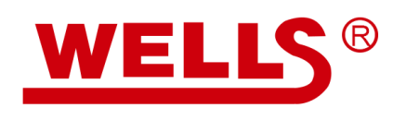

Translation, Polishing, and Proof-reading Services

Wells Information Services Inc. specializes in legal translation, language polishing and proof-reading services. Collaborated with The Foundation for Law and International Affairs Review, we are happy to provide such services to help authors for easy article submission. Further, we can provide Certificate of Proof-reading for your article when required by publishers.

- High quality Translation
- Language polishing
- Check grammar, spelling and punctuation
- Check format, terminology, and consistency
- Check style and expression
- Logical and sense review
- Proof-reading Certification and official invoice

If you need our services, please submit your paper to hanxiangting@wells.org.cn
Any question please call the number 010-88578296
For more information about Wells, please follow our Wechat account
